4. METHODOLOGY

4.2 Session Tracker
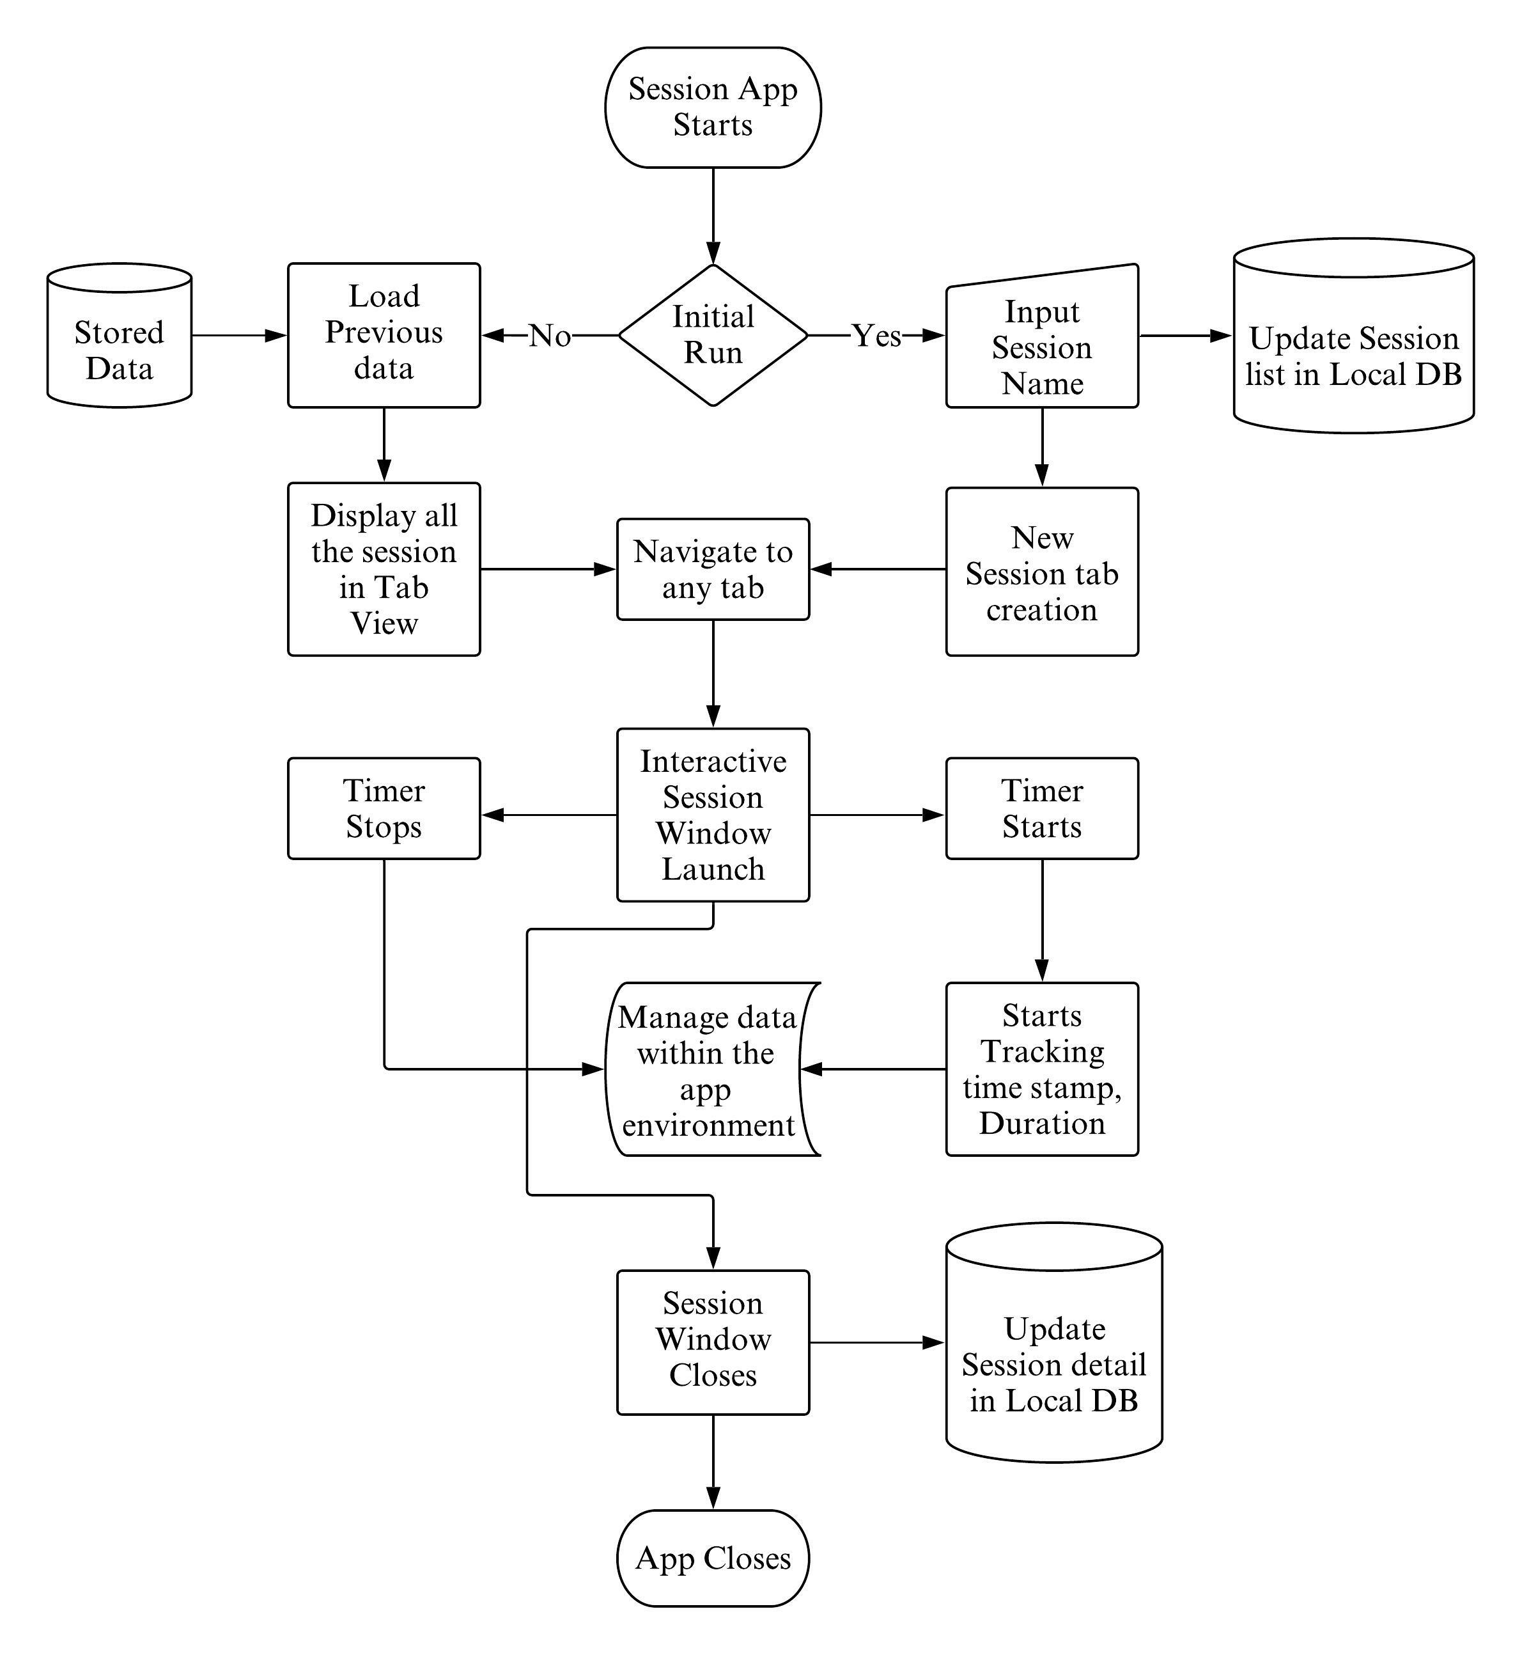
Figure 1: Flowchart for Session Tracker
The working of the whole ‘Session Tracker’ app is going to be based upon working with local database. Basic operations such as creating, reading, updating and deleting (CRUD) on the associated database is executed for the flow of any data and information in this app. Two scenario exist for the app based upon whether the app is being initially run or not. If the app contains no prior stored data, the instant the app is launched, two tables will be created in the associated database. On adding new session to the session tab, the session properties will be stored in the local database. The session listed is going to appear in their own separate session tab. On clicking the particular session tab, a new interactive session window will render in the main window. This window will contain a button that toggles between starting and stopping the session. On starting the session, the stop watch appears and starting counting every millisecond. On stopping the session, the time stamp and the duration of that particular session will be stored within the program. At exiting the app, the data temporarily stored in the container will be transferred to the associated local database.

4.2.1 Main Window Interface
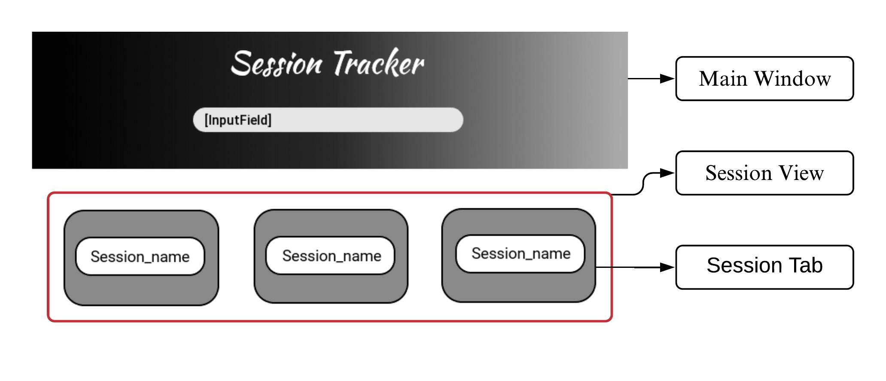
Figure 2: Main Window Layout

4.2.1.1 Main Window
SFML provides two different classes for rendering the window. The main window will be using sf::RenderWindow. Sf::RenderWindow provides useful methods such as polling any type of event within the window, extracting different properties of the window, clearing and updating the window, etc. The main window design contains the app title, an input field and a button that toggles and the session view. On clicking the ‘Add new session’ button, the input field appears. On adding the session, a new session tab in the session view will appear. All the required UI components will be built separately inheriting from SFML classes.

4.2.1.2 Session View
Viewing section will contain all the session tab. Every session tab will be equally spaced within the view. On exceeding the size of the view, the scroll effect will appear for the session view. For the implementation of scroll effect, sf::view with view port size as the session view will be set. There will be a maximum limit to how many tabs can be contained within the view.

4.2.1.3 Session Tab
Tab is going to be implemented using the round corner rectangle and a button within it. Each tab will have an event handler that detects the clicking of the tab button. The tab will then expand to the window size as new session window. The tab might contain associated information of the tab such as creation date and the stop watch info if any.

4.2.2 Session Window Interface
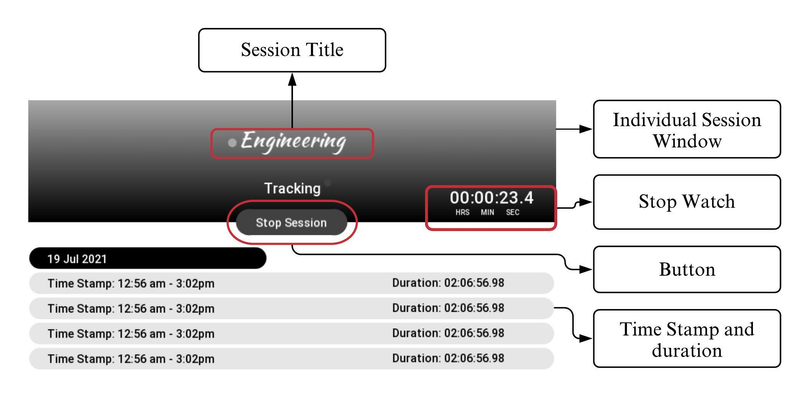
Figure 3: Session Window Layout

4.2.2.1 Individual Session Window
New session window will be rendered in the same main window. This window will contain the main aspect of the app. Its design contains the session name, stop watch, a button that toggles between start and stop session and the session details. This window will have the same dimension as the main window. The graphical design of the session window will contain the gradient background which contains the session name, stop watch and the button. The second part of the design will contain the session details in a tabular format.

4.2.2.2 Stop Watch
Stop watch records every millisecond of time using sf::Clock and its method getElaspsedTime(), asSeconds() and asMilliSeconds(). A conversion function will then convert the seconds into hour and minute. The stop watch will display the recorded time in [hour: minute: second. millisecond] format. This stop watch will be connected to the button. On clicking the start session button, the stop watch appears and start counting every second of time and updates the watch in the window.

4.2.2.3 Button
The button will act as toggle button between ‘Start Session’ and ‘Stop Session’. On clicking the stop session, the button will be replaced by the stop session and the stop watch starts. On clicking the stop session, the stop watch will stop and disappear and the detail of that particular session will be added to the session detail view.

4.2.2.4 Session Detail

